Main page

**Index**

|  |  |  |
| --- | --- | --- |
| **Sr. No.** | **Title** | **Page no.** |
| 1 | Project description |  |
| 2 | Software and Hardware requirements |  |
| 3 | ER-Diagram |  |
| 4 | Program flow diagram |  |
| 5 | Functional component |  |

1. **Project Description**

The Stack-Based Text Editor is a command-line Python application that enables users to create, edit, and manage text files dynamically. This project incorporates core functionalities of a typical text editor, including file creation, text insertion, deletion, undo, and redo actions. By leveraging stack-based operations, it efficiently handles complex editing actions, allowing for easy management of undo and redo functionalities.

The project is built to be user-friendly and extendable, with features including:

* File management: Users can create new files, load existing ones, and save changes.
* Text editing: Provides basic text insertion and deletion, with automatic space insertion for readability.
* Undo/Redo: The stack-based approach allows for tracking each action, making it easy to reverse or repeat recent changes.
* Dynamic interaction: The command-line interface supports a range of commands for flexible, user-directed editing.

1. **Software and Hardware requirements:**

Software requirements:

* Operating system: Any OS supporting Python (Windows, macOS, Linux)
* Programming language: Python 3.7 or above
* IDE/Text editor: Any IDE that supports Python, such as Visual Studio Code, PyCharm, or Jupyter Notebook
* Python libraries: No external libraries required

Hardware requirements:

* Processor: Minimum Dual-core 1.3 GHz or higher
* RAM: Minimum 2 GB
* Storage: Minimum 100 MB free space

1. **ER-Diagram:**

The following ER diagram outlines the relationship between the main entities in the Stack-Based Text Editor:

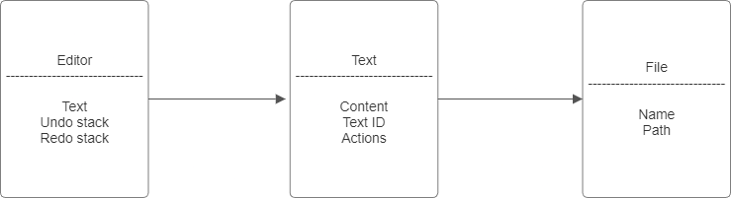

1. Program flow diagram:

The following flow diagram outlines the key program processes:

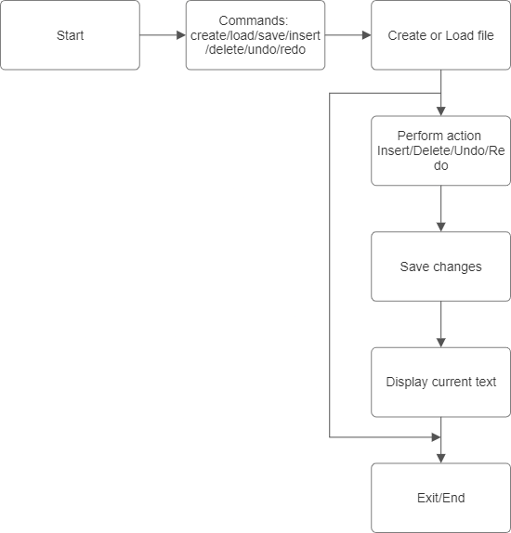

1. **Functional component:**
2. File management module:

* Handles file creation, loading, and saving.
* Sets the current file and updates the text editor's state.

1. Text editing module:

* Allows users to insert and delete text in the editor.
* Provides automatic space insertion for improved readability.

1. Undo/Redo module:

* Uses a stack to manage text changes and supports undoing and redoing recent actions.

1. Command-line interface:

* Offers an interactive experience with commands for each functionality.
* Accepts inputs for file management, text manipulation, and navigation commands.